# User Guide

* Introduction
* Overview
* Quick Start
* Features
* FAQ
* Command Summary

## Introduction

Welcome! This user guide will provide you with all the essential information required for you to make full use of our task manager, TasKitty.

TasKitty is a task manager that can help you manage events, deadlines that you have to meet, or simply tasks that you want to get done whenever you have free time.

If you are a keyboard lover and dislike clicking, then TasKitty is the right task manager for you! It boasts an intuitive command line interface with minimal clicking required, and the commands you have to type in are short and sweet.

-Taskitty



To get started, proceed to the Quick Start section below.

## Overview

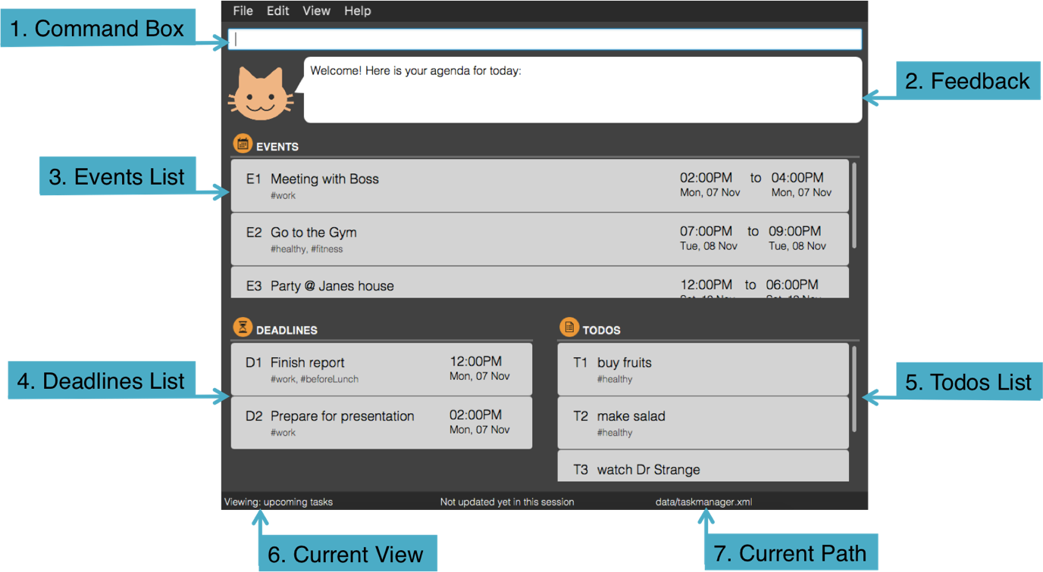

Figure 1: TasKitty Overview

1. This is the **Command Box** for you to type your commands
2. TasKitty provides **Feedback** for your actions here
3. **Events List**, where you can view all tasks that have a start and end date
4. **Deadines List**, where you can view all tasks you need to complete before a certain date
5. **Todos List**, where you can view all your tasks that you wish to do someday
6. This shows the **Current View** of the TasKitty. Here, it is showing the upcoming tasks
7. This shows the **Current Path** to the file where the data of TasKitty is stored. There are two types of file paths:
   * Absolute: The file path from the root folder

Eg. C:/TasKitty/data/taskmanager.xml

* + Relative: The file path from TasKitty

Eg. ./data/taskmanager.xml

**Quick Start**

1. Ensure you have Java version 1.8.0_60 or later installed in your Computer

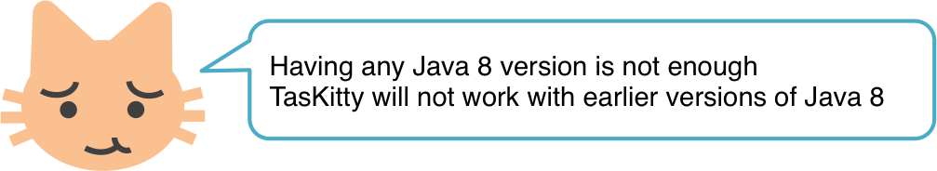

1. Download the latest TasKitty.jar from the releases tab
2. Copy the file to the folder you want to use as the home folder for TasKitty
3. Double-click the file to start the app. TasKitty should open in a few seconds.

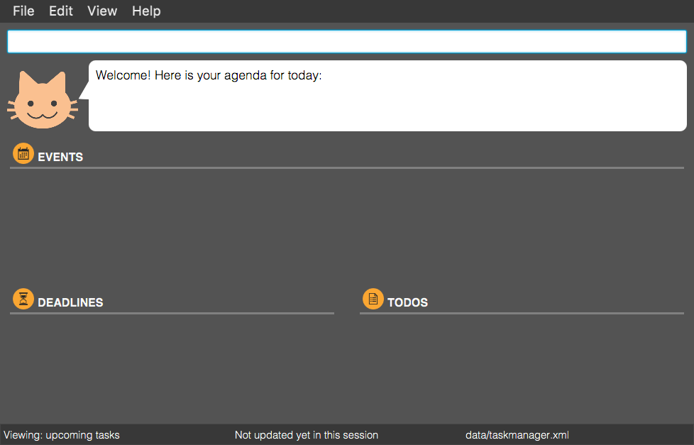

Figure 2: TasKitty Welcome Screen

1. Type the command in the command box and press **enter** to execute it

Eg. Typing help and pressing **enter** will open the help window



1. Some example commands you can try:
   * add read book - adds a new task named read book
   * add business proposal 17 nov 2pm - adds a new task that has the deadline 02:00pm, 17 Nov
   * view - lists all upcoming and uncompleted tasks
   * view 1 jan - lists all tasks for the specified date
   * delete d1 - deletes the 1st task shown in the current list of deadline tasks
   * exit - exits the program
2. Refer to the Features section below for details of each command.

## Features

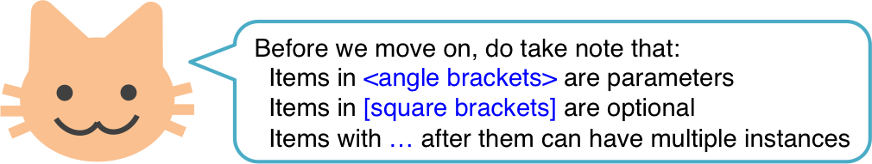

**Help: help**

Format: help

Shortcut key: F1

A pop-up window displaying the command summary will be shown.

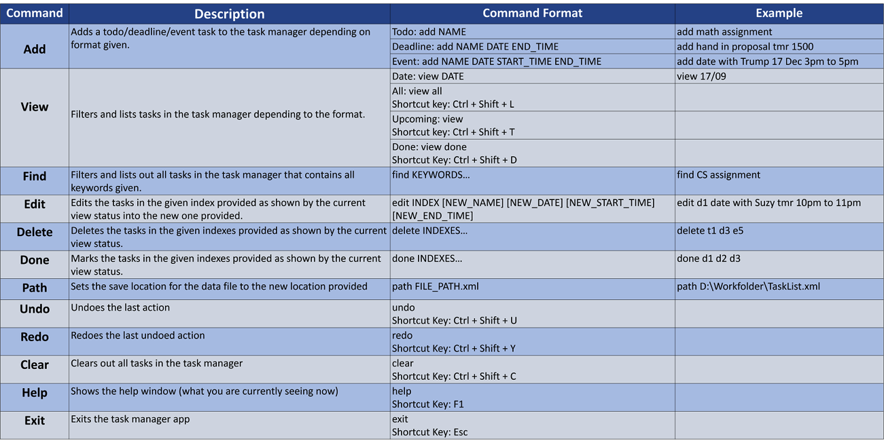

Figure 3: Help Window

**View Upcoming Tasks: view**

Format: view

Shortcut Key: Ctrl + Shift + T

Lists all upcoming and uncompleted tasks.

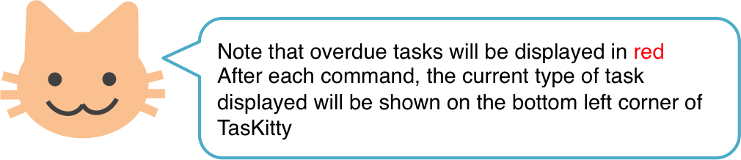

**Example:**

Command: view

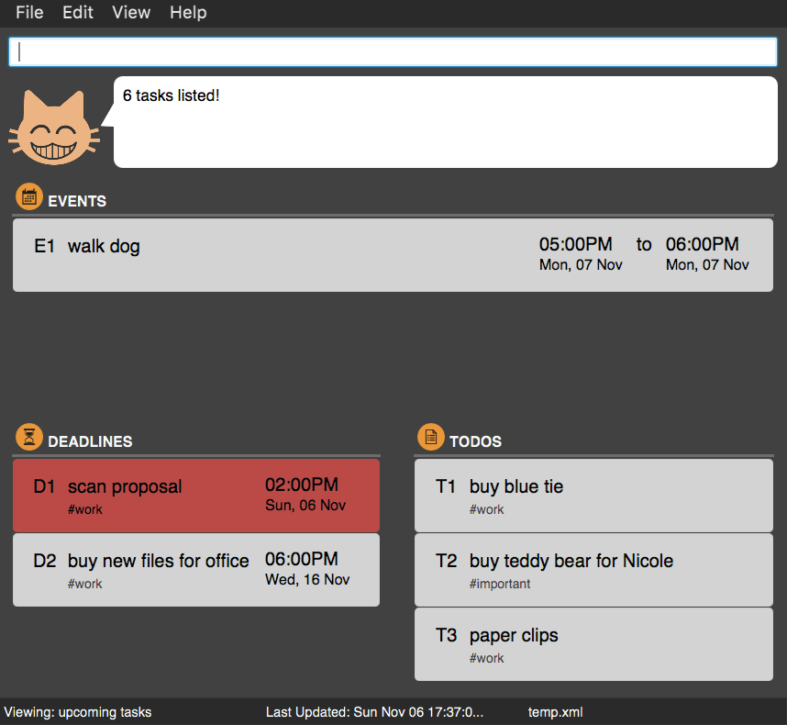

Figure 4: View Command

**View All Tasks For Specified Date: view <date>**

Format: view <date>

List all events for the specified date, uncompleted deadlines up to the specified date, and all todo tasks.

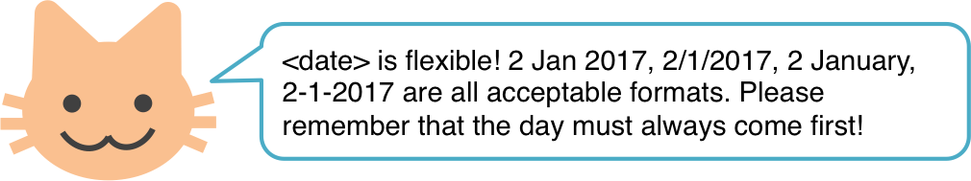

**Example:**

Command: view 7 Nov

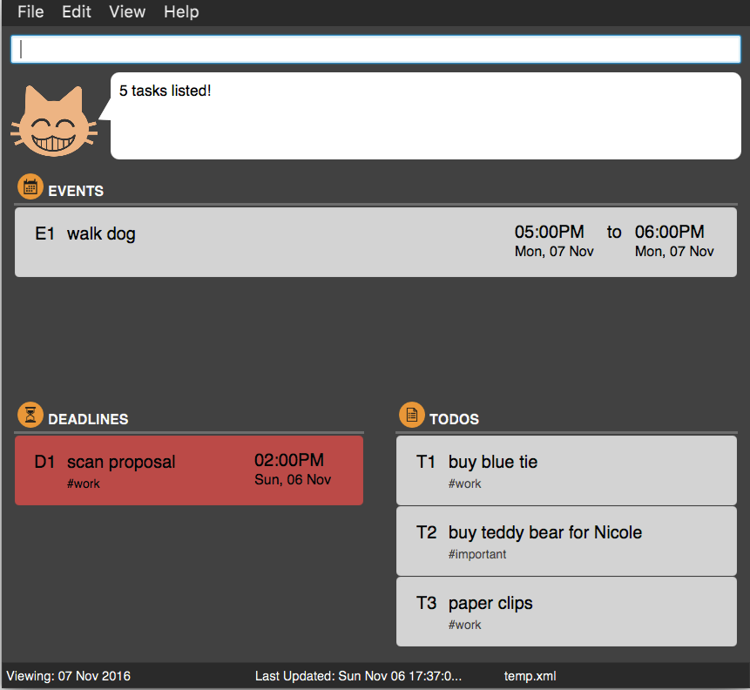

Figure 5: View <date> Command

**View All Completed Tasks: view done**

Format: view done

Shortcut Key: Ctrl + Shift + D

List all completed todos, deadlines and events. Tasks that are done will be shown in grey.

**Example:**

Command: view done

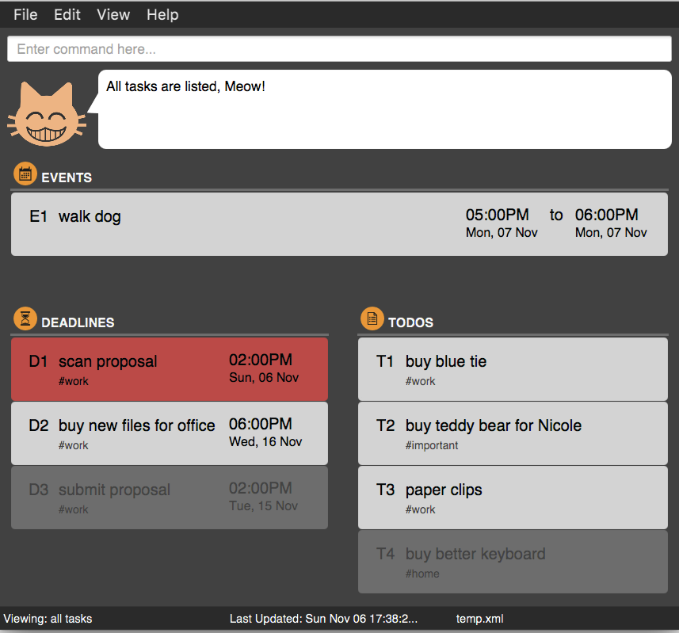

Figure 6: View Done Command

**View All Tasks: view all**

Format: view all

Shortcut Key: Ctrl + Shift + L

List all todos, deadlines and events that have been added to TasKitty, including events that have passed and done tasks.

**Example:**

Command: view all

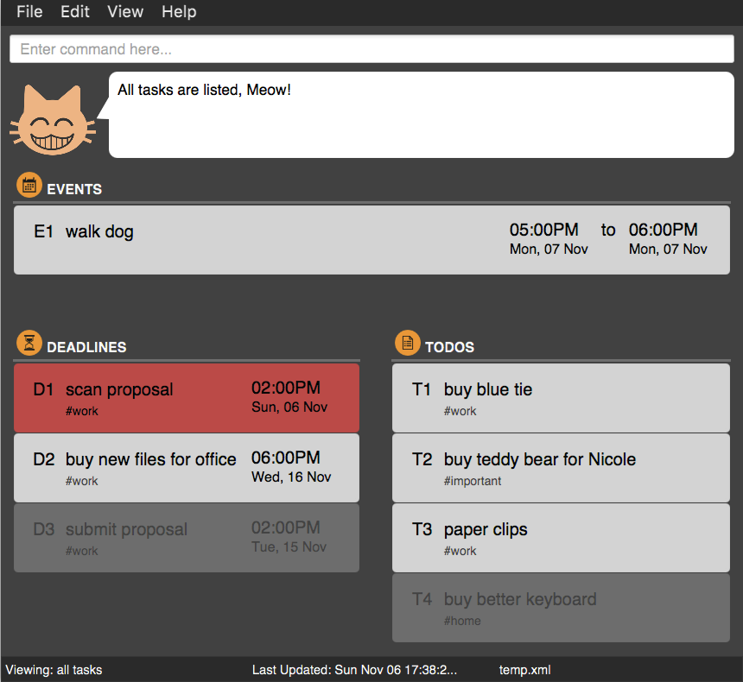

Figure 7: View All Command

**Add New Task: add**

Format (Todo): add <name> [#tag]…

Format (Deadline): add <name> <end datetime> [#tag]…

Format (Event): add <name> <start datetime> to <end datetime> [#tag]…

Adds a new task to the todo, deadline or event list in TasKitty.

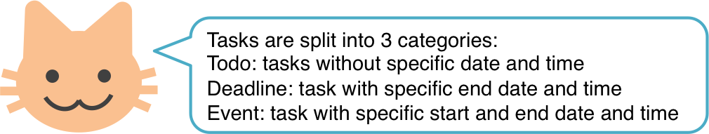

**Example (Todo):**

Command: add buy new tie #work

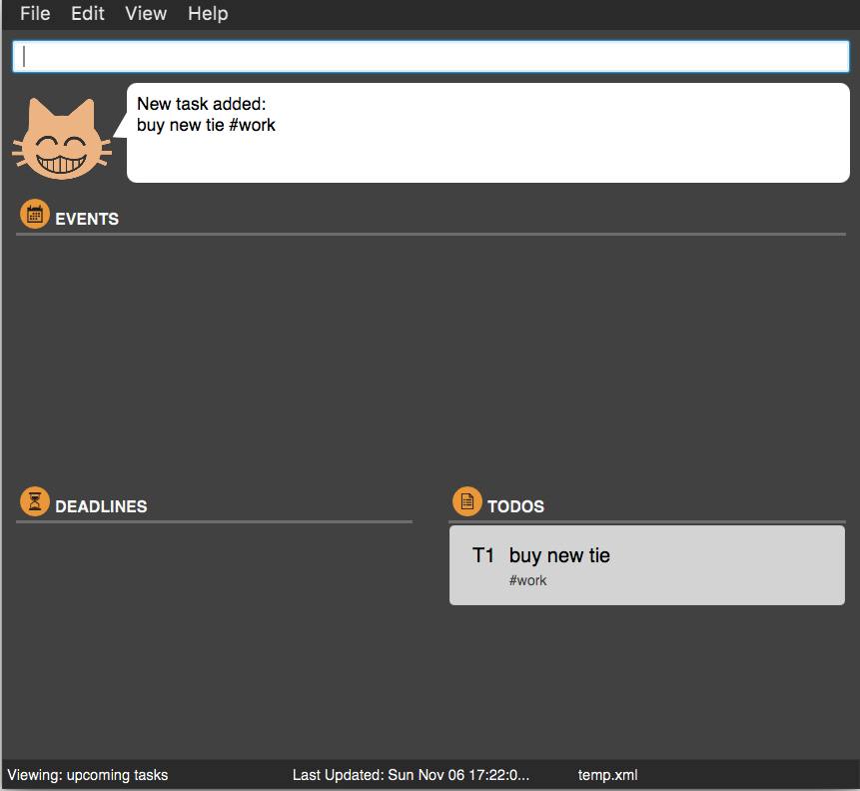

Figure 8: Add Todo Command

**Example (Deadline):**

Command: add submit proposal 17 Nov 2pm #work

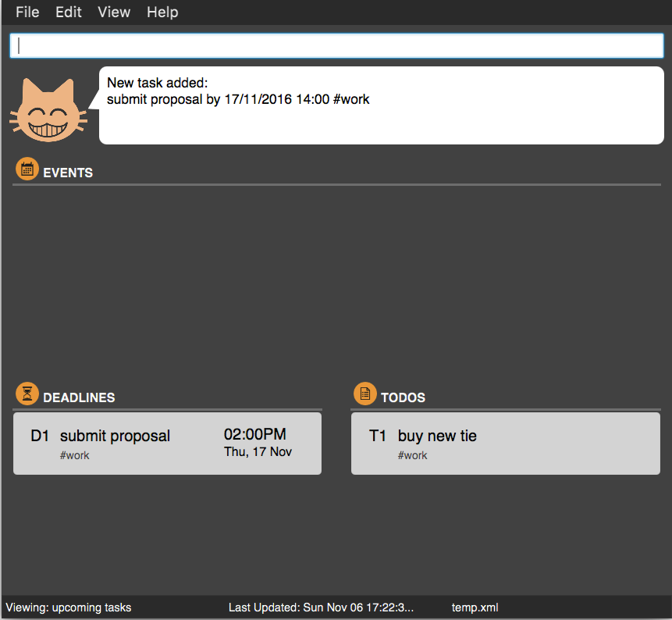

Figure 9: Add Deadline Command

**Example (Event):**

Command: add walk dog 7 Nov 2016 17:00 to 18:00

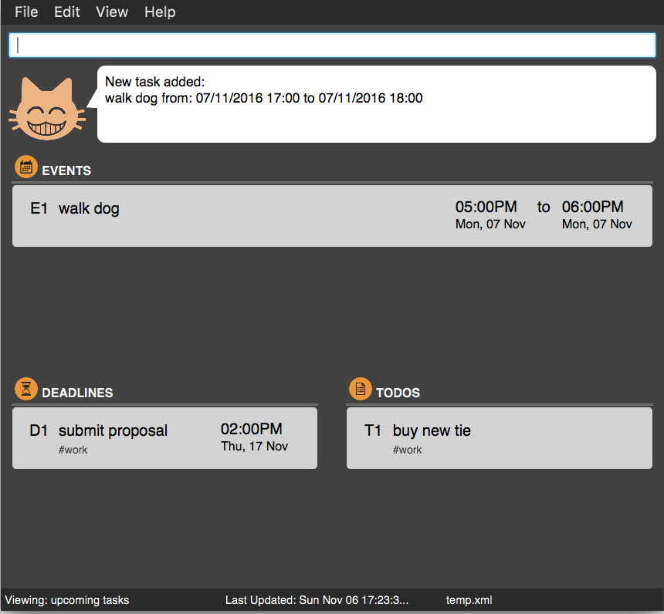

Figure 10: Add Event Command

**Find Task: find**

Format: find <keyword>…

Finds tasks based on keywords. Tasks that partly or completely match keywords entered will be displayed. You can also find tags using #.

**Example:**

Command: find prop

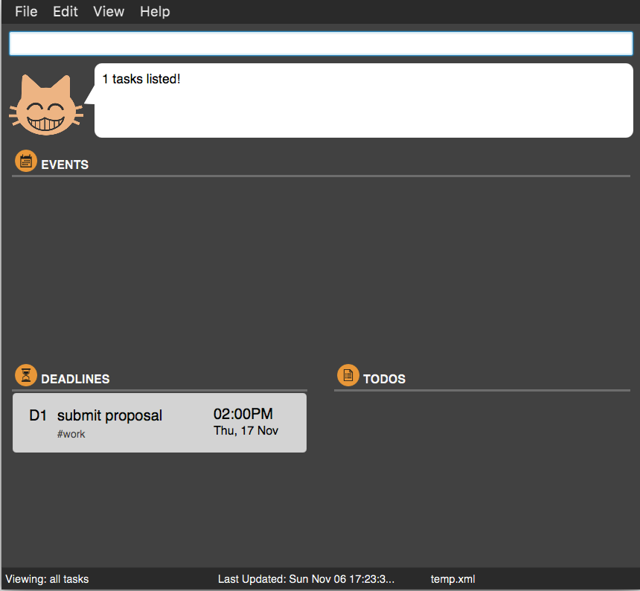

Figure 11: Find Command

**Example:**

Command: find #work



Figure 12: Find Tag Command

**Edit Task: edit**

Format: edit <index> [new name] [new datetime]

Edits a todo, deadline or event already inside TasKitty using the index of the task. Format depends on the type of task being edited. When only 1 <time> is provided, it is treated as <end time> for both deadline and event.

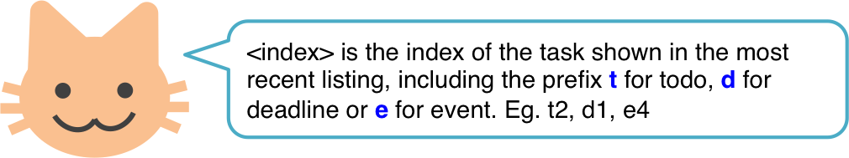

**Example:**

Command: edit d2 16 Nov

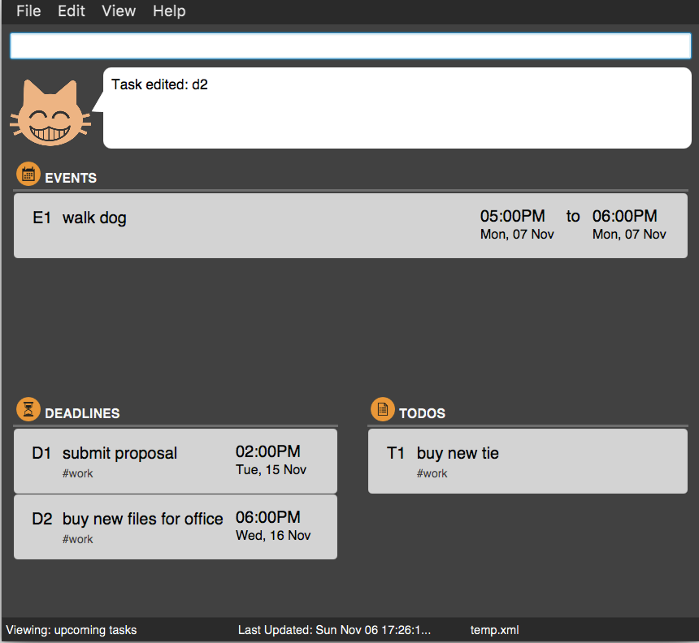

Figure 13: Edit Date Command

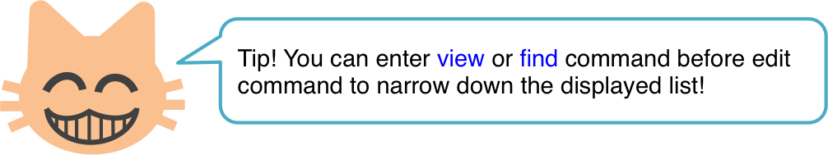

**Example:**

Command: view

edit t1 buy blue tie

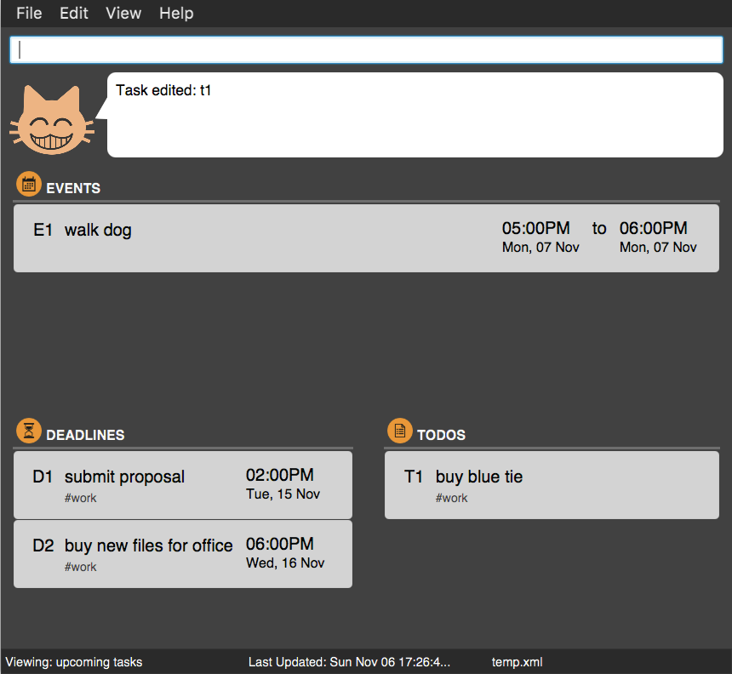

Figure 14: Edit Name Command

**Delete Task: delete**

Format: delete <index>…

Deletes one or more todo, deadline or event tasks already inside TasKitty using the index of the task.



**Example:**

Command: view 7 Nov

delete d1

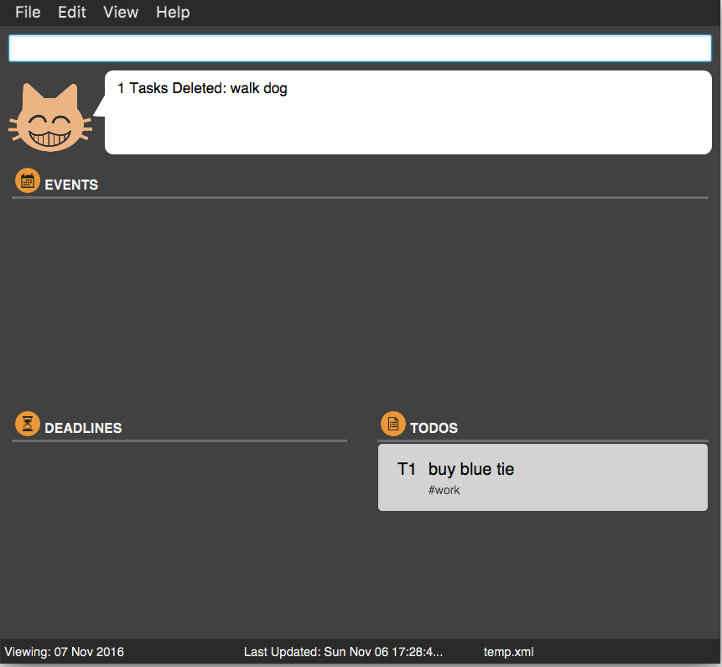

Figure 15: Delete Command

**Example:**

Command: view

delete t1 d1 e1

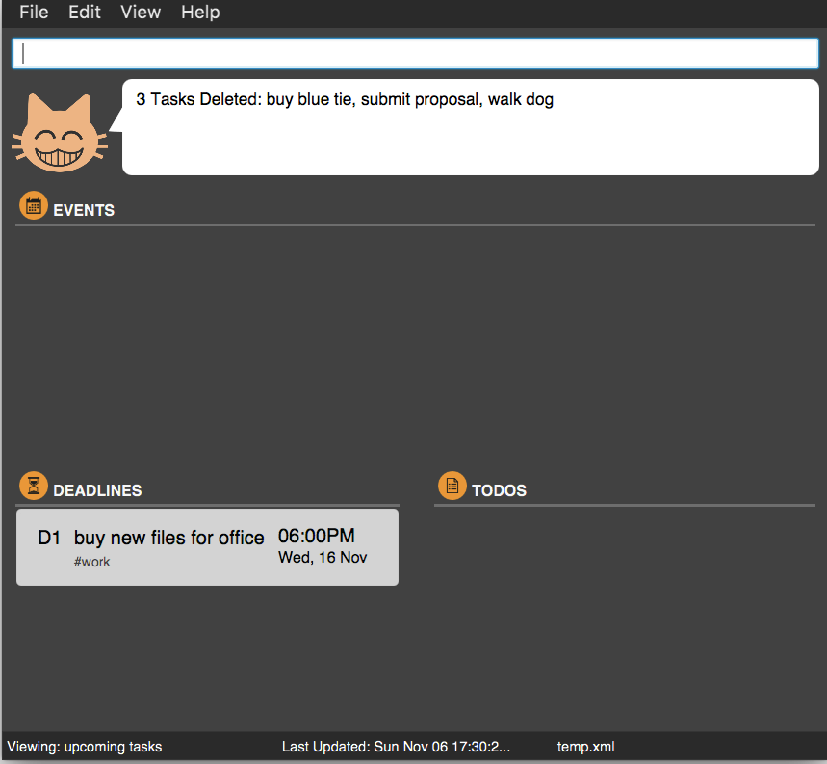

Figure 16: Delete Multiple Command

**Mark Task as Done: done**

Format: done <index>…

Marks one or more todo, deadline or event tasks already inside TasKitty as done using the index of the task. Tasks that are marked as done are moved to the bottom of their respective lists.

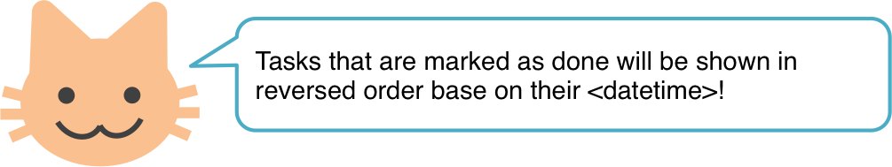

**Example:**

Command: view all

done d1

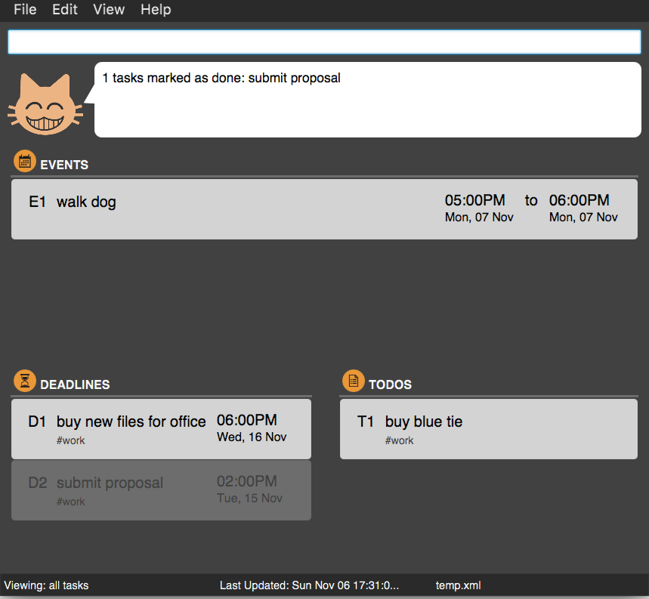

Figure 17: Done Command

**Example:**

Command: view all

done t1-3

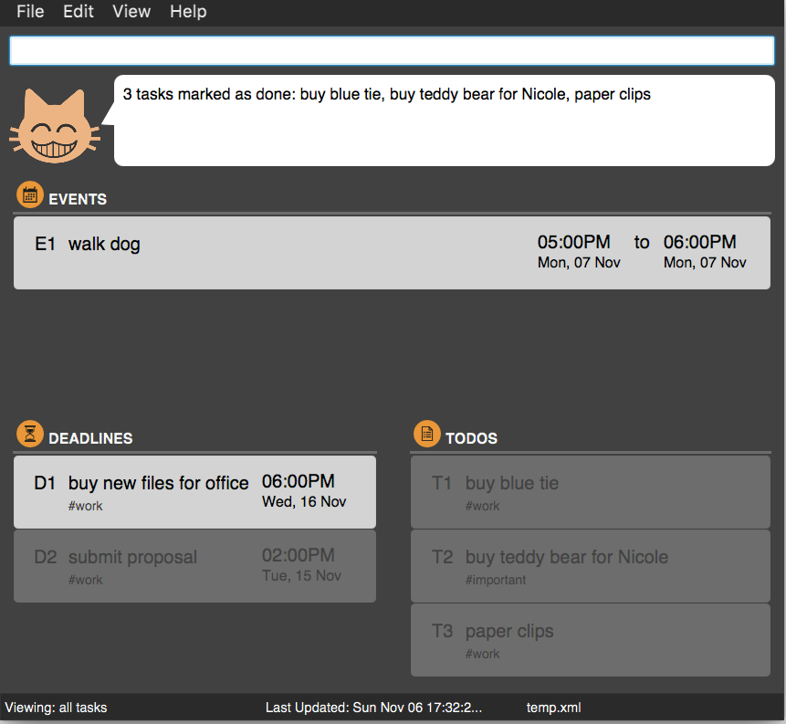

Figure 18: Done Multiple Command

**Undo Previous Action: undo**

Format: undo

Shortcut Key: Ctrl + Shift + U

The previous action will be undone. You can undo as many times as you want until the start of the current session.

**Example:**

Command: delete t1

undo

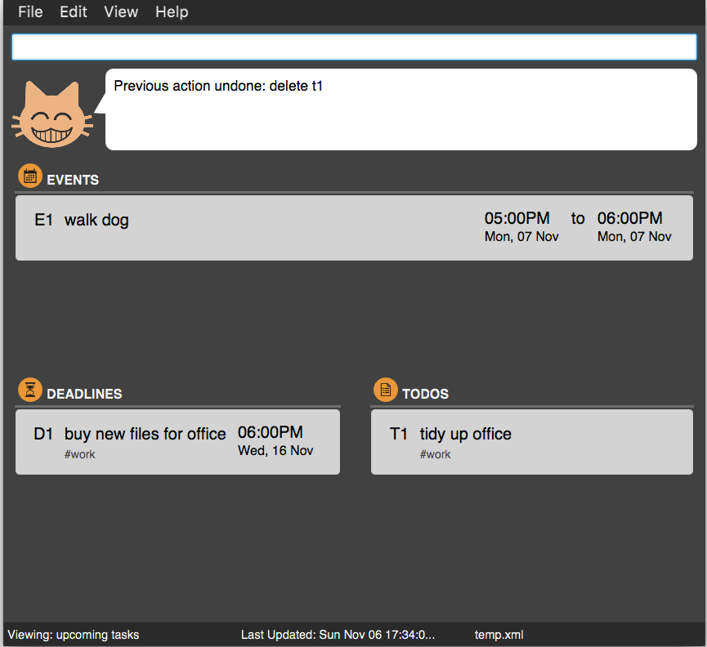

Figure 19: Undo Command

**Redo Previous Undo: redo**

Format: redo

Shortcut Key: Ctrl + Shift + Y

The previous undo will be redone. You can redo as many times until the latest change.

**Example:**

Command: redo

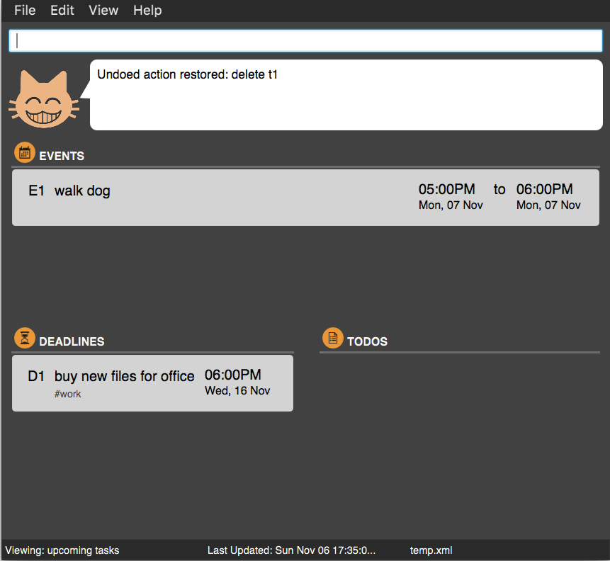

Figure 20: Redo Command

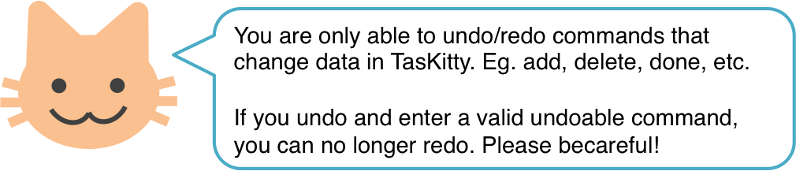

**Save or Load Data: path**

Format: path <filepath>.xml

Saves the data to a specified folder. TasKitty will automatically create the folder if the folder is not present. Data will be loaded from an existing file only if TasKitty is currently empty.

**Example:**

Command (Mac): path /Users/TasKitty/Desktop/TasKitty.xml

Command (Windows): path C:\TasKitty\Desktop\TasKitty.xml

**Clear All Data: clear**

Format: clear

Shortcut Key: Ctrl + Shift + C

Clears all the data in TasKitty.

**Exit TasKitty: exit**

Format: exit

Closes TasKitty.

## FAQ

**Q**: The app is not recognizing my tasks correctly!  
**A**: Try to use "quotes" around your task names to help TasKitty differentiate between your task name and other parameters.

**Q**: How do I transfer my data to another computer?  
**A**: Install the app in the other computer and overwrite the empty data file it creates with the file that contains the data of your previous task manager's folder.

## Command Summary

|  |  |
| --- | --- |
| add todo | add <name> [#tag]…  Eg. add grocies #milk |
| add deadline | add <name> <end datetime> [tag]…  Eg. add hand in proposal tmr 1500 |
| add event | add <name> <start datetime> to <end datetime> [tag]…  Eg. add date with Trump 17 Dec 3pm to 5pm |
| view date | view <date>  Eg. view 17/09 |
| view upcoming | view or Ctrl + Shift + T |
| view all | view all or Ctrl + Shift + L |
| view done | view done or Ctrl + Shift + D |
| find | find <keyword>…  Eg. find work |
| edit | edit <index> [new name] [new datetime]  Eg. edit d1 date with Suzy tmr 10pm to 11pm |
| delete | delete <index>…  Eg. delete t1 d3 e5 |
| done | done <index>…  Eg. done d1 d2 d3 |
| path | path <filepath>.xml  Eg. path D:\Workfolder\TaskList.xml |
| undo | undo or Ctrl + Shift + U |
| redo | redo or Ctrl + Shift + Y |
| clear | clear |
| help | help |
| exit | exit |